23. Draw a Line Chart Using Values Taken from a Text File
import matplotlib.pyplot as plt
x = []
y = []
with open("data.txt", "r") as file:
for line in file:
values = line.split()
x.append(float(values[0]))
y.append(float(values[1]))
plt.plot(x, y)
plt.xlabel("X Axis")
plt.ylabel("Y Axis")
plt.title("Line Chart from Text File")
plt.show()
OUTPUT:
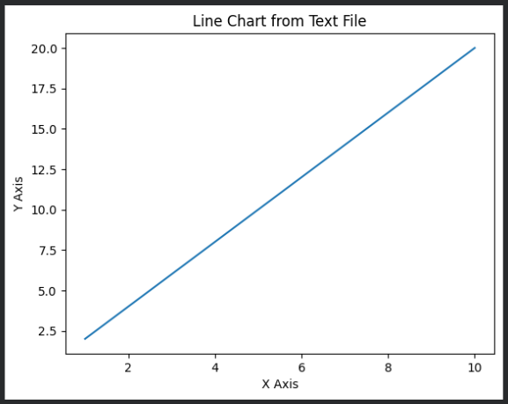

24. Draw Line Charts of Financial Data
import matplotlib.pyplot as pl
date = ['Jan', 'Feb', 'Mar', 'Apr', 'May', 'Jun']
open_price = [100, 105, 110, 108, 115, 120]
close_price = [105, 108, 112, 115, 118, 125]
plt.plot(date, open_price, label="Open Price")
plt.plot(date, close_price, label="Close Price")
plt.xlabel("Month")
plt.ylabel("Price")
plt.title("Financial Data Line Chart")
plt.legend()
plt.show()
OUTPUT:
